

Decision support system



# Table of Contents

Table of Contents 2

**Abstract**: 5

**Introduction**: 6

**Model Management System**: 6

**Users Interface**: 6

**Knowledge Base**: 6

Figure#01: Decision Support System 7

**Properties of DSS**: 7

**Drawbacks of the decision support system**: 7

Figure#02: Limitations of DSS 8

**Source:** 8

https://mscisbolouereifidi.wordpress.com/2015/03/05/decision-support-system-review-decide-and-act/ 8

**Heuristics**: 8

Figure#03: Heuristics 9

**Background**: 11

Figure#04: Framework for warehouse design and operation issues 13

**Aims and Objectives**: 14

**Literature review**: 14

**Methodology**: 16

**Layout**: 16

**Allowance**: 17

**Assignment**: 18

Figure#05: Methodology for the DSS solution development 18

Figure#06: DSS top-down decisional methodology 19

**Several situations are simulated**: 19

**The DSS's design and operation**: 20

**Database consideration**: 21

**Graphical user interface**: 21

Figure#07: A field scale DSS 22

**Layout user interface**: 22

Figure#08: Data needed to construct a DSS for storage problems 23

**Allocation graphical user interface**: 23

**GUI for Assignments**: 24

**Simulator user interface**: 24

**Decision Support System Limitations**: 25

For years, firms have used technology to support decisions to improve people's minds. These systems are not without drawbacks, though. DSSs do not stop decision-makers from fostering partiality, rather helps to make decisions with readily digestible portions of relevant information. In order to avoid an overview, all physical information should be shown in the form of graphs, photos or text. 25

This is not a good signal to rely on and place an excessive level of confidence on the decision support system. DSS contains several uncertainties, such as: 25

**Difficulty Quantifying All Data**: 25

**Disappointment of System Design**: 25

**Exertion Collecting All Required Facts**: 26

**Users' lack of technological knowledge** 26

**DSSs' Drawbacks**: 26

**Information Overload** 26

**Too much reliance on DSS** 26

**Subjectivity is devalued** 26

**Overemphasis on Decision Making** 26

**Cost of Development** 26

**Fear of Learning** 27

**Getting Out of Your Comfort Zone** 27

**Fear of Using New Technology** 27

**Project design:** 27

**The "High Income" cluster:** 32

**The "Have Kids & Teens" cluster:** 32

**The "Advertising Campaigns" cluster:** 33

Figure#09: UML diagram of DSS 49

Figure#10: Class diagram of DSS 50

**E-R diagram of DSS:** 51

Figure#11: E-R diagram of DSS 51

**Source:** https://www.researchgate.net/figure/General-system-diagram-The-main-tasks-of-DSS-is-verification-formatting-storing_fig1_221916051 51

**Conclusion**: 51

**References**: 56

# **Abstract**:

The word DSS is commonly taken into account in particularly complicated circumstances with variations in the problem or organization of work. Web - based application DSS allows key managerial, often in real life, nevertheless often not in use. The management of resources includes the proposal and administration of hayloft arrangements (sales centers) that satisfy suppliers and demands, facilitate the season, concentrate goods and arrange distribution activities. Storage arrangements show a significant part in guaranteeing customer happiness and productivity. A multitude of challenges are posed by the warehouse architecture, including design limitations and operational concerns, which have a significant influence on performance and logistics costs. This study proposes a novel DSS system for warehouse systems design, administration and management. Most of the suggested DSS employs a top-down technique to create and manage large warehouses. The DSS can imitate logistics and material management performance in storage systems. Heuristic techniques and algorithms address many significant warehouse concerns, including order collection, which accounts for 55 percent of the whole distribution center. The advantages of implementing the recommended methodology to decision making are aligned with the summary table of the key KPIs, allowing providers, managers, academics and trainers to seek guidance for managing materials in real-world storage systems.

The combination of modern data mining technology and big data development has allowed corporations to obtain a new advantage over their opponents in maximizing their data understanding. Better technology for data extraction and analysis makes business decisions more efficient. This research incorporates machine learning as an algorithmic entity and applies it to existing companies. It concerns facts that impact corporate decisions and provide insightful feedback that may successfully contribute to decision-making.

People become more conscious of their environment and engage with the world more than before. Although this is a benefit, it is dynamic and chaotic that increases demand and the global market. In order to keep the time up, an infrastructure has to be able to preserve the changing nature of the worldwide market. This uncertainty may be expressed by heuristics guided by probability. The results of this research will analyze the global market conditions using this data collection and analyze the exploratory scenario. It also offers data-driven solutions and extensive data visualization.

# **Introduction**:

The Decision support system is an administrative platform that helps a company to determine the activities, evaluations and solutions needed. The information system aids corporate management at the middle or high levels by processing huge volumes of unstructured data and gathering information that can solve problems and make decisions. A DSS is driven by humans, either automatically or both.

A decision-making system provides comprehensive information reports via data collecting and processing. A DSS is thus distinct from a conventional operational application for data collecting and not data analysis.

Strategy formulation departments - such as the Department for Logistics - use a DSS in an organization to collect data and make management decisions. DSS is mostly used for sales, stock and operational data and is rapidly comprehended for customer information.

A DSS may be utilized in principle in many areas of competence, from organization to forest management and medical practice. Real-time reporting is one of the company's most crucial DSS applications. For companies concerned in the management of just-in-time inventory, it may be quite valuable.

In a JIT supply chain, the company needs stock actionable insights to place orders "in good time," avoiding delayed production and generating a negative domino effect. A DSS is therefore more individually or corporately customized than a standard system.

Three foundational pillars of the DSS approach are:

## **Model Management System**:

Model Management Program contains models that may be decided by management. The models are used to evaluate the financial health of the organization and foresee of demand for a product or service.

### **Users Interface**:

The functionality may travel via the DSS end user's system.

### **Knowledge Base**:

The knowledge base comprises internal and external information (in a transaction process system) (newspapers and online databases).

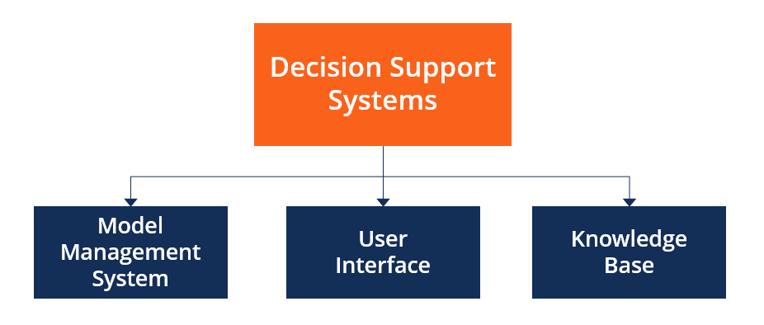

# Figure#01: Decision Support System

**Source:** https://corporatefinanceinstitute.com/resources/knowledge/other/decision-support-system-dss/

## **Properties of DSS**:

* A decision help system enhances speed and efficiency of decision-making. DSS can collect and assess data in real time.
* It promotes corporate training since particular skills in the construction and management of the company's DSS must be established.
* Optimizes repeated management processes that allow the manager to decide for longer time.
* Increases communication inside the firm amongst personnel.

## **Drawbacks of the decision support system**:

* The cost of building and deploying a DSS is an important money expenditure which makes it less affordable for smaller enterprises.
* A company may depend on DSS to boost efficiency and speed via integration into daily decision-making processes. However, managers are overly reliant on the technology that eliminates the decision-making subjective aspect.
* A DSS may lead to overload since all the aspects of a situation are taken into consideration by an information system. For end customers, it presents a dilemma since they have various options.
* The deployment of a DSS might cause personnel at lower levels to fear and reverse. Because many of them are uncomfortable with contemporary technology and are afraid of losing their jobs.

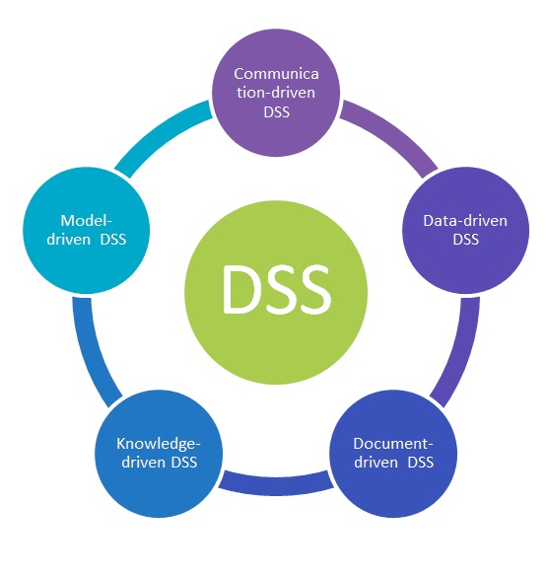

# Figure#02: Limitations of DSS

**Source:**

https://mscisbolouereifidi.wordpress.com/2015/03/05/decision-support-system-review-decide-and-act/

# **Heuristics**:

The approaches obtained through previous meetings with similar problems known as heuristics. These strategies depend on the use of information, however freely adaptable, to manage problem solving in humans, robots and abstract problems. (The Jewish City of Pearl, 1983) When a person does a heuristic, he typically works as planned. Alternatively, systemic mistakes may occur (Sunstein, Cass, 2005).

The most important cognitive evaluate and trial, from comparing fasteners and pins to finding variable values in mathematics issues. The use of visual representations, supplementary assumptions, forward/return argumentation and reduction are typical mathematical heuristics. Some of the strategies often employed in George Pólya's 1945 book: how to deal with the issue:

* + Try creating a graph if you find it difficult to understand an issue.
  + If a solution cannot be found, attempt to suppose that you've got a solution and see what that means.
  + Try to investigate a specific situation if the topic seems abstract.
  + Try to handle a broader issue at first.

Psychological heuristics are basic and effective principles that are learnt or altered by evolutionary processes that explain how humans select, make judgements or solve issues regularly under challenging conditions or information. Researchers evaluate whether these instructions are implemented in different ways. In most circumstances, these principles work effectively, but in some settings they may lead to structural mistakes or ideological component.

Heuristic evaluation is an inexpensive assessment methodology used to discover usability problems at different stages of a project. A small group of evaluators who monitor the system by system-relevant heuristics or principles comprises a heuristic assessment.

Heuristics are common or common understanding of design. They may often function as a learning tool and grow into building design models such as software engineering. It enables ideas to be translated into an universal understanding and promotes the utilization of established processes or principles (E. Gamma, R Helma, R. Johnson and J. Vlissides, publishers, 1994). Further heuristics may be more general and design choices may be controlled. As a tiny, economical, speedy and easy-to-use approach, heuristic assessment may be utilized in development iterations. It may be used in the creation, assessment and even before the first operational prototype for paper-based ideas is built.

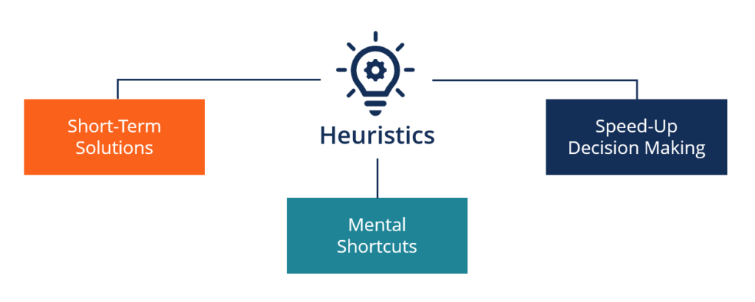

# Figure#03: Heuristics

**Source:** https://corporatefinanceinstitute.com/resources/knowledge/other/heuristics/

Although heuristic testing has long been a component of HCI (J. Nielsen and R. L. Mack. usability inspection techniques, John Wiley & Sons, Inc., 1994), the InforVis evaluation was not equally used or investigated. There are additional usability concerns with these systems, however they are not the only ones. We are studying problems which need different or other criteria to evaluate InfoVis discount systems. We investigate LuMPB Key (Mountain Pine Beetle Key), a visual decision support system for simulation data testing, in a case study using a series of heuristic devices for these systems. We assess the effectiveness of heuristics employed for following investigations and present implications for the heuristic assessment process in InfoVis.

For three primary reasons, most practical optimization issues cannot be resolved perfectly:

* + There is typically a shortage of accessible environmental information characterizing our condition. In order to approach the best answer, the missing parts must be predicted.
  + The information supplied is sometimes too complicated to absorb accurately and fully. This makes it desirable that even when algorithms sacrifice quality solutions, they require less computer resources.
  + Systems in the current world continue to improve, developed it unrealistic to use one explanation persistently. This comes as no surprise for new data to rapidly change strategy.

Machine learning was seen as an approach to everything above. Normally a master training model with appropriate training data can recognize the near best hypotheses which represent regularity in training data, which tend to transfer into unexplored settings (C. Zhang, S. Bengio, M. Hardt, B. Recht, Vinyals and O, 2017). Profound knowledge models may, in particular, learn hierarchical data representations such that in a compact (and hence quick) structure they acquire increasingly complicated regularities (Y. e. a. Bengio, Learning Deeper Architectures for AI, 2009).

Machine learning is not always easy to implement despite its promise to optimization challenges. The solution (or a solution template more correctly) should frequently be broken into smaller components, which possess certain properties at least. Each component is picked from a range of alternatives in sequential or random order. This begins a decision-making process in which stakeholders may choose between people, professional coordination, brainy erudition organizations or a mixture. If the components do not share commonalities, several methods for each choice are necessary. Sometimes dividing the reaction into smaller components is easier. For example, the TSP solution may simply be divided into a number of basic choices. A Job Store Scheduling Problem may be used to detach one solution from the work of every machine (decentralized) or to identify what each machine is doing with other machines.

But it is not as evident how the reaction might be broken into smaller components. For instance, it is not evident how the design is to split into smaller components that the difficulty is to identify the ideal form for an airliner nose cone, according to given requirements. This is why simple forms like understandable geometries are commonly employed (JHuwaldt, 2018). Judgments of several geometric components, for example, such as nose radius, pitch, length etc. may make the cone form blunt.

When the solution structure for the solutions requested has been constructed, automated learning is used to build models to make these choices autonomously and responsively. The trouble is to identify the right approach for machine learning and how to get data for training and how to train and utilise the model. This conclusion does not differ from the structure of the solution. The solution frequently is best separated into components with comparable characteristics and based on a clearly defined set of facts. For the Algorithm, more complicated decisions based on a wider range of inputs are likely to be part of a centralized system. Therefore, with simpler decision makers, the decentralized option should be used on the basis of less evidence. If the decentralized solution is effectively built, a machine-learning perspective may be shown (T. Riedmiller and T. Gabel, 2005)

# **Background**:

Companies have completely altered their ordinary manacles in recent years to meet increasing purchaser facility requirements and unexpected claim. Warehouses serve a vital role in the supply chain and storage demands have significantly expanded. Customer expectations and new demand patterns have drastically changed in terms of order correctness, response rate, order frequency, quantity and order size (e.g., e-commerce). The works thoroughly investigated warehouse design and management to lower the operating, operational and performance expenses of the supply chain. Comprehensive study on warehouse and industrial warehouse systems has been offered (De Koster et al, Gu et al. and Dallari et al). The warehouse systems are mainly responsible to receive and maintain things, remove goods from stocks and transfer them according to customer demands.

This graphic provides a conceptual framework in which warehouse activities are classified, which encompasses definitions, methods, measurements and system choices of components. Large units like cargo and containers or pallets are frequently obtained via goods which minimize labor and handling expenses. Products must be removed, the warehouse's most important task.

In order to satisfy client needs, the storage system converts huge and often consistent resources into tiny, common and diverse outputs. When the client order lists are finished, small and frequent production volumes occur. The collection of orders is one of the key work and storage expenses components. Two more alterations are made to the arrangement. One is the so-called tiered collection available by collecting equipment from storage sites (e.g., turret-trucks). The further, the so called front replacement, picks a low level from an affordable front that is a bigger reserve store's most important supply of commodities. When a product has a short inventory, it gets re-filled from the reserve. A description of zoning, batching and routing will be offered in storage for a complete elucidation of the patterns in the proposed framework. Zoning consists of separating the warehouse into several zones according to the workstations. Pickers will be allocated to areas and each order will be ordered and delivered by the staff from area to area. The loading of a single picker needs numerous orders. Batching is an excellent way of saving travel, however recovered SKUs should be sorted in one order. The route recognizes the right sequence of the order list to guarantee the correct warehouse route.

Two key components contribute to enhanced performance:

* warehouse design
* operational management

The first section is concerned with layout limits and constraints, storage devices and high-level strategic decisions for the whole facility stock. The second concerns warehouse activities such as replacement, re-filling and order collection which are based on models, strategies and techniques aimed at improving operational efficiency (e.g., zoning, batching, routing). These two factors have a direct influence on the operation of the warehouse and on the quality of service of the whole logistical chain.

The research has a wide spectrum of KPIs in the warehouse including spectral efficiency, storage space, reaction time (when ordering and shipping times, cost, and unit pricing of supply chain given by the storehouse), material flow processing through the warehouse per unit time. The space and time management which is essential for every logistics job affects all these measures. Literary contributions often focus rather than on warehouse management independently on the theme of warehouse design. Gu et al. (G.Gu, M.Goetschalckx, L.F. McGinnis 2007) discuss the in-and-out methods and examine the literature, the studies are categorized according to the analysis, the techniques used and the warehouse type.

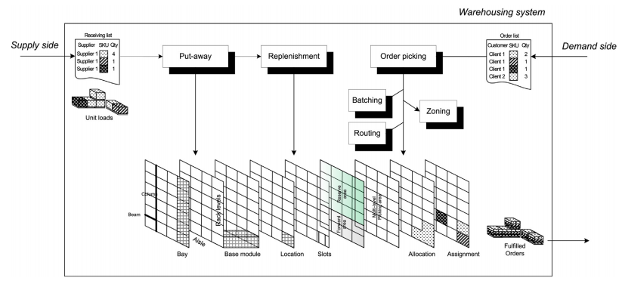

# Figure#04: Framework for warehouse design and operation issues

**Source:** https://corporatefinanceinstitute.com/resources/knowledge/other/decision-support-system-dss

The rest of this research will show how warehouse operations are designed and managed strategically by using a decision-making support system (DSS). It facilitates the development of complicated forward-looking picker storage systems and multi-scenario modelling of KPI storage evaluations. In order to enhance data analysis and performance, the DSS employs a variety of heuristic approaches.

Storage systems and processes are managed and controlled (i.e., industrial storage systems) from a range of design options to numerous competences. For example, interconnected areas are difficult to tackle but can be tackled by formulating models of the process, including the layout-design issue, the definition of total storage capacity, the determination of alloy numbers, types of racks and locations for products in the storage region (e.g. storage unit and SCU), an inventory by SKU, etc. The bulk of the literature reviews concentrate on a certain part of the warehousing problem that does not incorporate multi-use methods.

In the proposed DSS, it is possible to design and evaluate various setups and scenarios in a user-friendly computer environment using a top-down technique. It employs multi-scenario simulation technology for handling real-world cases, explaining the interdependence of alternatives and providing suitable recommendations on warehouse problems.

DSS is a computer-based tool that has been designed to make challenging decision-making possible and easier. In this area, research often underlines the relevance of IT for boosting user efficiency, choice and efficiency. The literature highlights, in particular, the advantages of employing computerised logistics management systems in the fields of logistics, transport and storage.

# **Aims and Objectives**:

The purpose of this study project is to analyze current market trends by means of data-driven analysis and to deliver data-driven market solutions. This is performed by the following steps:

* Analysis of exploratory data:
* Check for zero values and outliers.
* Features that need transformation.
* Features that may be generated from current data or detection of anomalies.
* Multiple linear regressions have to be carried out for statistical analysis in order to accomplish the following:
* Factors connected to number of shop purchases.
* Comparison of the US and the globe with respect to total purchases.
* Verifying the hypothesis:
* Visualization of the data o Most successful marketing campaign.
* The viewpoint of an average consumer for a business or Best performing items.
* Channels of underperformance.

# **Literature review**:

Literature offers a broad variety of KPIs including transmission capacities (storehouse processed forwarder node per unit of time), system capacity, low latency (if requested and given, expenses and expenses per unit of inventory supply chain). All these aspects are affected by the time and space management requirements for any logistic work.

Literary contributions often focus on warehouse design rather than warehouse management alone. Gu et al. (J. Gu, M. Goetschalckx, L.F. McGinnis, Warehouse Operations Study 2007) discusses re-examined literature and methods and categorises research, technology and shop-based papers.

Rouwenhorst et al. (B. Rouwenhorst, J. van den Berg, R. Manteler, H. Zijm, 199) and Svestka (J.A. Svestka, 1989) facilitate the design and reconstruction of customized pallet charging systems by means of interactive decision-making (i.e. unit load). Other studies suggest OPS (e.g. SKU master file, master order file, master stock file) handling approaches for operational data analysis (i.e. loading below the unit size) (T. Govindaraj, E. Blanco, D. Bodner, M. Goetschalckx, L. McGinnis, G. Sharp, 2000).

The Data warehouse does not presently provide a single scientific contribution that can unify warehouse design and modes of operation.

The proposed DSS is written in a high-level, relational database computer language that gathers, stores and manages data from a real-world warehouse instance. Tens or hundreds of thousands of SKUs are gathered every year by storage systems based on customer requirements from millions of orders, coordination of incoming activities, quality control and delivery schedules. Industry invests in the development of integrated storage systems for this reason (WMS). These business solutions provide an idea of processing materials in real time and generally advise the optimum use of space, effort and equipment (P. Helo, B. Szekely, Logistic information system, 2005). WMS solutions are still management tools for firms without participation in the design and decision-making of warehouses.

The lack of a defined strategy in that area underscores the need for a DSS that can gather reality data and apply strong heuristics to swiftly develop and manage warehouses. This effort seeks to build a unique DSS Architecture for evaluating storage systems that takes care of design, storage equipment, assignment and task elements.

The predictable consequences of the recommended system may be utilized to diffuse data among logistics providers, practitioners and managers, to educate and develop engineering know-how and to analyze case studies in the current environment. The Decision Support System (DSS) has evolved and produced artefacts and research together with other information systems in the last 40 years (IS). The current language of DSS includes "big data," "business intelligence" and "analytics." The content of the 9 mini-tracks approved by the Decision Support and Analytics Interest Group of the AIS The developing character of the region is seen in (SIGDSA). Either "analytics" or "big data" are included in all nine mini-tracks. Likewise, in AMCIS 2016, all seven SIGDSA mini-courses had the identical phrases. This shift in terminology and focus has led some DSS scientists to debate the relevance of early DSS papers in current and future studies. In this article, the continued importance of early DSS research is addressed in the future study of present and future computerized systems in order to facilitate decision-making. We have chosen the MIS Quarterly, one of the early academic journals and one of IS's major publications for its first 15 years, to study in depth, rather than analyzing the hundreds of DSS documents produced between 1969 and 2001 (Eom, 2003). In 1977, the first issue of MIS Quarterly came out and much of the MIS is available on its pages. Although DSS research was published by conferences and other publications during that era, many of the most rigorous, relevant and novel DSS research articles were submitted each two months to the MIS and rigorously examined by its peers. We picked the period from 1977 to 1991 because of the increase in the number of quality DSS publications with the publication in the late 1980s of Decision Support Systems and ISR (ISR). Although the number of articles evaluated may be enlarged or extended to more basic articles or includes management science, interfaces and decision-making, there is relevant and practical information continuing attempts to examine rigorously 30 DSS works.

We also assess the significance of computerized decision support theories, concepts and points of view, which might further enrich current research and foster study in the future. As Mason, McKenney and Copeland (1997, p. 307) report on a history of the field: "This provides a backdrop to determine what is unique in the present scenario and what components aid to separate the present situation from any previous circumstances. Helps to comprehend the roots of problems today... Identifies strategies that have been and have not been successful in the past. It reminds us that any actual event has a broad range of complexities, complexities and unpredictability." A MIS perspective offers an inductive framework for future study and inspiration for new research hypotheses (Mason et al. 1997).

# **Methodology**:

The decision support system proposed a top-down strategy to develop and manage a prospective OPS. This technology organizes techniques, models and algorithms to give organic sequential choices with a large variety of storage, storage and storage solutions. In order to examine different storage configurations utilizing simulation of what if various situations, the policymaker conducts a series of analyses. The objective is to reduce the overall journey through picking, which represents 55% of the warehousing costs. Distance reductions include minimizing the number of solutions required to manage travel materials (for example, chariots and guided vehicles) for transporting material, decreasing congestion in automobiles, car parking places, travel, maintenance, work and other outputs. The feedback loop allows the user to reorder selections in the store room proposal and work to attain efficiency. The main decision-making steps are concentrated in the following parts.

## **Layout**:

The first choice is the standard specification. The studies of the system development are followed by an analysis of the power consumption of the structure. The suggested technique is based on previous stock and competitive pressures as an input to a risk assessment study to calculate the warehouse system's required internal storage.

The objective is to develop the organization structure by defining a number of criteria, such as the form factor, the number of aisles, the number of hallways per column, the size, the kind of racks and the features of the unit. The DSS simplifies the whole storage space by splitting various areas into discrete SKUs, which may require certain equipment or sets.

## **Allowance**:

The storage allotment methods determine a fraction of a generic SKU's total accessible storage space in the forward field provided a specific time horizon is available. The Equal Space (EQS) approach offers all SKUs the same room, whilst the Equal Time Strategy (EQT) assures that each SKU has the same inventory time horizons. Both are recognized to the business and appropriate for all storing conformations (i.e., cartons-cases picking). The Optimum Approach (OPT) of Bartholdi and Hackman, and formerly Hackman and Rosenblatt reduce the re-taking in the front region of smaller parts. In order to provide alternate inventory conditions for each SKU, the proposed DSS employs many so called allocation algorithms. The stock selection for future use by each SKU (i.e. rapid picking or low-level location) effects regeneration operations and collection processes, since this option changes the positions of the SKU. The technique also allows for an SKU model, which maximizes the net advantage of the frontier region both in terms of a selection of time savings (i.e., selection from the front compared to reserve selection) and recharging times. In this phase, the judgement maker analyses the consequences of the allocation with layout features to finally consider relocation.

At this step, the chief analyses the distribution findings with the design highlights and lastly considers the possibility of re-designing. The capacity task systems create suitable places for the SKUs according to particular criteria. The DSS requires that the chosen SKUs function for a specified time within the required profile. Data on selection actions are gathered to present an SKU characterizing measurement board. Another crucial point of view for the recommended DSS is the consumers' link between the SKUs. Associated task arrangements may be developed for collecting and assigning SKUs to nearby skills to save money on travel needed for exercises. The respective methodology consists of three basic steps: The following are the following:

* Towards the correlation of research. The degree of connectivity is usually examined when an SKU comparability file is presented. This approach allows the comparison of generally relevant similarity files, e.g. the Jaccard list and specific difficulties.
* Clustering: this stage involves selecting many bunching levels (e.g. single connection, whole connection, regular bunch) and different thresholds of closeness for dendrogram reduction (i.e., esteem based, percentile-based).
* Consignment of the clustering assignment. This approach involves the processing of measurements (e.g. prominence, rotation, shutting) for each group of SKUs (e.g. the prominence of a bunch is supplied by the overweight of the lead of the SKUs) and also classifying the SKU bunches.

## **Assignment**:

The work procedures on capacity provide the right space for SKUs based on exceptional criteria. The DSS searches for behavior from chosen SKUs within the request profile over a defined spell period prospect. The selection data is gathered in order to generate an SKU organization measuring board. In specifically, a file-based job strategy outlines the overall layout of SKUs according to practical needs including ubiquity, rotation, form per request, and request closure. A new written commitment is suggested to provide such heuristics and methodologies more clearly for index-based task groups.

Another crucial feature that might be taken into consideration in the proposed DSS is the relation between the SKUs that customers jointly seek. To save the time spent travelling to select operations, correlated assignment rules may be used to group SKUs recommended together and allocate them to neighboring storage locations.

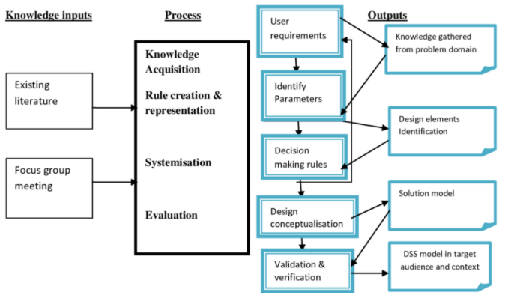

# Figure#05: Methodology for the DSS solution development

**Source:**

https://www.researchgate.net/figure/Methodology-for-the-DSS-solution-development-in-forestry-pest-management-partly-adapted_fig1_261352085

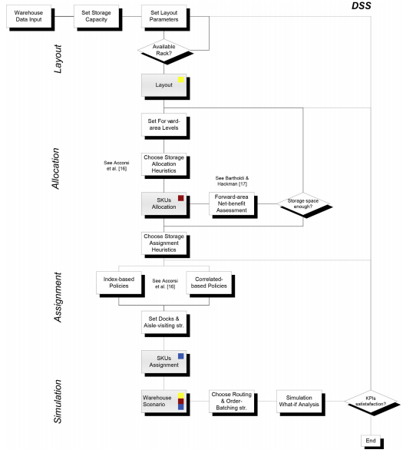

# Figure#06: DSS top-down decisional methodology

**Source:** Accorsi, R., Manzini, R. and Maranesi, F. (2014) “A decision-support system for the design and management of warehousing systems,” Computers in industry, 65(1), pp. 175–186.

## **Several situations are simulated**:

In the past, the DSS handled a number of choices (e.g. requirements analysis, task and assignment) that result in a given warehouse setup. Numerous warehouse scenarios, each with unique architecture, storage allocation and storage assignment criteria, may be built using multiple rounds of the DSS. Finally, by limiting overall journey distance, time and cost, the decision maker may establish the optimal solution for storehouse development and implementation if multi-scenario simulation of the operator's performance (i.e. travel for throw, fill-up, and picking).

The DSS's latest organization of options provides an explicit arrangement for a stockroom scenario. Different DSS emphases contemplate developing various stockroom circumstances that differ in their design arrangement, stockpiling percentage, and stockpiling job standards. Consider a situation in which a multi-scenario reenactment of useful demonstrations enables the leader to choose the greatest solution for the stockroom plan and the executives by minimizing total voyaging distance, time, and expense.

## **The DSS's design and operation**:

The DSS is a valuable and developer device for organizations who are not familiar with coding or web engineering but often deal with warehouse system design and operational problems. The DSS utilizes DBMS structures for the storing of data, models, heuristic algorithms and learner database management systems for interactive consultations, reporting and graphical visualization. The proposed application is built on top of a self-contained database.

Warehouse practitioners manage decision making inputs such as operational features, expenditures and other features, while operational KPIs are generally evaluated in the actual domain (e.g. pick-rate, picking spell and preference travel). Users may access, save and manage massive amounts of data fast using the SQL database architecture that can be acquired via dynamic requests. In addition, a graphical user interface, which is designed using AutoCAD1, is used to automatically build graphical 3D representations of warehouse situations.

The programme is arranged around a primary GUI, which displays all the key features and instructions for importing and saving data or projects. The following are the main characteristics of the tool:

* Make a whole new storage system.
* Import the current layout for examination of allocation-assignment.
* Run DSS to get a complete study of the structure, allocation and assignment of a generic granary area (in line with warehouse zoning).
* Fusion into a consolidated system single many storeroom regions (i.e., in line with warehouse zoning).
* Storage, task, solitary instruction picker direction-finding and command batching all heuristics need to be implemented.
* Create a what-if analyze with multiple possibilities for warehouse KPIs.
* Create a 2D/3D visual warehouse that matches a range of circumstances.

## **Database consideration**:

All DSS heuristics, processes and analyses are based on aggregated database historical data. This section highlights the development and application of the proposed DSS. The huge volume of data that warehouse operations manage is essential. For example, in the automotive industry, replacement parts storage and management systems, which handle huge numbers of SKUs, collected every day from multiple locations to meet dozens of requirement lines. In general, warehouse management systems are used to supervise warehouse activities. The initial step of the analytical procedure is to filter the available historical data (e.g. SKU effective data, stock, and demand) in order to generate a comprehensive autonomous collection according to the organizational architecture.

The database management system designed works as a connection between the information and the product owner. This program requires a considerable number of data to be processed, so that the attributes of the storage system can be clearly defined.

This system uses a related Access TM-driven SQL structure, but may be replaced by any commercial database management system. A series of columns in the data base provide a full description with a typical snowflake structure of the study aim of the system. For the creation of an insightful structure using the application and to keep code of modifications, preliminary research into the integrated design patterns and E-R charts are essential.

The architecture of this database provides various advantages. It helps users to manage stocks and to identify a generic SKU for newcomers in storage areas. A warehouse system performance dashboard may be constructed with numerous dynamic views and queries.

GUIs are used for building a subscriber appearance on the client side. The responsible party must choose to construct a warehouse area from the outset, add a new zone to an existing store or transfer an overall inventory area to evaluate the assignment (i.e., a brown-field scenario).

A benchmark is completed to assess the success of each scenario and to assess the effectiveness of the predefined assignment and assignment criteria when low- and mid-simulations of the put-out, refill and order selection activities (e.g. picking) are performed. As a batching tool to improve pick performance, a heuristic problem is generated and a batching approach that is based on a proposed system is constructed as a routing instrument.

## **Graphical user interface**:

Graphical user interfaces are a kind of user interface used to display user information. The user may use GUIs for analyzing and deciding in the DSS. A main window toolbar may be used for loading or saving a program. Throughout each execution, the user selects the analytical item's field and data set. The data and conclusions are presented in a short report on computer processing at the bottom of the control panel. Several storage alternatives may be devised for each project. What if dynamic simulation-based experimental research may be employed in different configurations and operating scenarios to examine the performance of the warehouse system? The findings obtained and the KPIs are presented and placed in the necessary database tables at the conclusion of each simulation.

One benefit of recording every success is the potential to provide essential recommendations based on the findings and administration of complicated storage systems. The graphical user interface consists of numerous components, explained further in the following paragraphs.

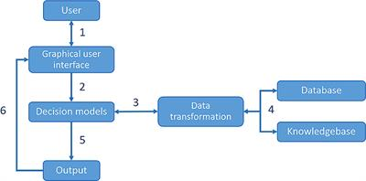

# Figure#07: A field scale DSS

**Source:** https://www.frontiersin.org/articles/10.3389/fenvs.2019.00115/full

## **Layout user interface**:

The decision maker decides the warehouse's total holding capacity to begin the design of the warehouse system. Based on cultural requirements or stock information, the customer has to maintain the overall inventory level and manage the available space effectively. The proposed DSS regulates the form factor, unit load dimensions, load placement unit, base component sizes, shoulder width and number of rack types for the layout design.

The overall capacity, aisle and bay, storage saturation (ratio of storage volume to the total available volume), as well as the number of SKUs kept on an aisle or bay are represented in this GUI.

The DSS determines the 3D coordinates of all locations once the storehouse has been formed and stores them for future simultaneous data analyses (or imported). The DSS also includes an AutoCAD1 application that utilizes current global library racks to formulate a comprehensive and three-dimensional storage proposed framework.

This tool allows researchers and logistics service providers to integrate module elements (such as beams and columns) from manufacturer catalogues and construct a truthful, realistic design of warehouses. The system calculates the maximum inventory weight and ensures that the needed rack components are available in the relevant dimensions and qualities. This provides a preliminary estimate of the total investment with the entire list of components.

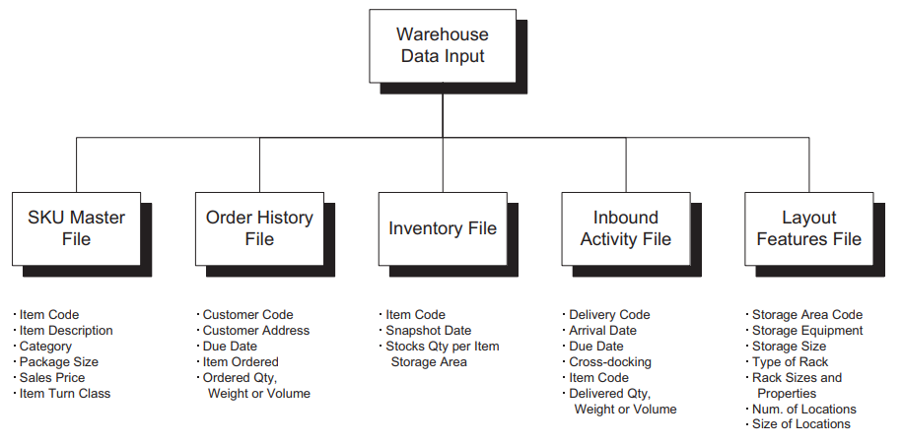

# Figure#08: Data needed to construct a DSS for storage problems

**Source:** https://corporatefinanceinstitute.com/resources/knowledge/other/decision-support-system-dss

## **Allocation graphical user interface**:

This graphical user interface enables the user to examine several allocation algorithms for a generic SKU for a common gap-life picker fork-lift picker forklift For a standard OPS fork-to-part fork-to-part picker, OPS for a typical fork-lift picker fork-up for a normal pick-up lift. The DSS incorporates four key allocation algorithms, one of which, the so-called EQT*, offers the right storage space for each SKU according to the recovered volume and demand for pick lines. This module is publicly created to allow other forms of allocation to be readily included in the future.

It depicts the graphical user interface given by the decision maker. To the left, two command windows are used to configure the rack's number and allocation for the forward area ('rack level (n.) and 'allocation strategy'). Therefore, the user may build a low or high level picking mechanism that allocates the larger levels to the processing power in the resource. Dynamic SQL queries are used by the schedule display to filter information and select the research horizon.

Different time lots are used to calculate the proportion of storage space given for each SKU based on past request and inventory data. For example, a panel assigns storage space, boxes and loads in a temporary batch in the forward area for each SKU. Storage space is generally a major resource for cost reduction. The decision maker may now take into account the net benefit of the future area.

The greatest curvature value shows the SKU subset that optimizes the tangible gain of the front area. The database updates an AS-IS inventory for each SKU when an established logistics region is imported and loaded. The user may bypass the assignment modulus that is not included in the assessment and continue straight from the design module to a storage assignment issue.

## **GUI for Assignments**:

This GUI leads to better decision manager face the task by determining the right spot to allocate a generic SKU in the future. The employment of a clustering approach, taking the analytical horizon account, classifies SKUs according to a set of criteria or methods for analyzing the link between SKUs. According to the technique, both options generate a list of SKUs, calculate finally the SKU's clusters, react to specific criteria (see the above popularity, order turns and closes) and are adequately combined with the list. There are more than 20 possibilities for the transport and receipt of docks, such as corner, center, bottom-up, once to regulate the arrival of a generic site.

Once the delivered SKU is in the appropriate direction, greedy heuristics are used to organize the reserve in order to minimize the gap between the item and your reserve. The outcomes of the task mechanism are stored in a database and are shown as a bird's eye view of the selected storage area. The perspective of the bird is a picture of the SKU placing each SKU color and summarization of storage data, e.g. location code, item code and carton number per item. The DSS also fills the rack in a three-dimensional layout with the SKUs. The decision-maker utilizes the real trading rack to print the planned warehouse version that is useful for equipment and systems manufacturers and suppliers as well as for slaughter and picking operators in storerooms.

## **Simulator user interface**:

Several kinds of racks or storage equipment are used in warehouse operations to allocate various categories of SKUs to the various areas according to the form, volume, weight and size of their packaging. Several configurations of the storage zone are recorded and then decided by the decision-maker to be consolidated into one system and created separately using the previous GUIs.

This GUI allows us to create adaptable and complicated warehouses including numerous warehousing areas as usual in real-world warehousing scenarios. In addition, this GUI helps the decision making process, which integrates what-if simulation analysis. The decision maker imports geographic co-ordinates for each area and arranges them according to the overall warehouse layout configuration, i.e. the merger of the warehouse consisting of one or more warehouse areas. The DSS determines the forward area for each site and reserves the travel path (in terms of kilometers) from and from ports of delivery and receipt.

The analysis of what-if simulation includes incoming, for example, puta way and outgoing, for example, pickup orders, activities and is an important instrument to measure system performance and expenses, namely travelling distance and time within a certain research horizon. The DSS provides a significant number of data and KPIs to measure the efficiency and efficiency of the layout, assignment and assignment settings. Statistics include the distance, time and horizontal travel due to the pick-up route, the travelling distance and time due to removal and replenishment, the time lost due to stock-out, the number of refuel lings per SKU, the number of hubs visited as a metric of vehicle jams, the spatial pick-up density, etc.

## **Decision Support System Limitations**:

For years, firms have used technology to support decisions to improve people’s minds. These systems are not without drawbacks though. DSSs do not stop decision-makers from fostering partiality, it rather helps to make decision with readily digestible portions of relevant information. In order to avoid an overview, all physical information should be shown in the form of graphs, photos or text.

This is not a good signal to rely on and place an excessive level of confidence on the decision support system. DSS contains several uncertainties, such as:

### **Difficulty Quantifying All Data**:

The majority of decision support systems are based on observable data. As a consequence, it is difficult to analyses etheric or indefinable data. Currently, certain quantities cannot be quantified or quantified easily. Although a DSS can quantify some of these elements, decision-makers need to take consideration of the total result. They must depend on their own judgement in making the final option.

As a judgement call, you may not be fully cognizant of the arguments presented in evaluation data on a given instance by a decision-making assistance system. Decisions may be risky without taking account of unpredictable situations. A decision maker must be aware that a computerized DSS is only helpful. The limits and preconceptions of an unsettled or partly organized environment must be carefully examined.

### **Disappointment of System Design**:

Management information systems are customized to the decision-needs. maker's Unless you know what you want a DSS to accomplish or how it should aid you, a system that meets your requirements cannot be designed. And you don't necessarily get the results you want when you are using a large DSS. Such situations may arise as a result of the system design flaw.

### **Exertion Collecting All Required Facts**:

As a verdict, you must realize that you cannot immediately gather all the required facts. Although certain data are hard to obtain, others cannot be captured. The value of a DSS may thus not be totally accurate.

**Users' lack of technological knowledge:**

Although decision-making tools have become much more comprehensible over time, many decision-makers still find it problematic to use. The absence of technological know-how remains a concern.

### **DSSs' Drawbacks**:

In addition to constraints, assistance systems for decisions have other downsides, including:

**Information Overload:**

Overloading of information during use of a computerized decision-making system may occur. Since all components of a problem are examined, it leaves the user uncertain what to consider and discard. Each piece of evidence is not necessary to conclude. However, it is difficult for a decision maker to reject information that is not vital if it is accessible.

**Too much reliance on DSS:**

It is true that decision-making assistance technologies are implemented into companies to assist workers make everyday decisions faster and simpler. Some decision-makers get used to depend too much on automated decision-making and refuse to utilize themselves. Obviously, the focus has changed and decision makers cannot further improve their skills because of their over-dependence on DSS.

**Subjectivity is devalued:**

A system of decision support fosters rational decision making by offering objectivity-based solutions. Even when restricted rationality or circumscribed irrationality plays a significant role in decision making, subjectivity cannot and should not be neglected. A DSS promotes objectivity while relegating subjectivity, which may have a substantial impact on the ends of a corporation.

**Overemphasis on Decision Making:**

The objective of computerized decision-making is clearly to always consider all parts of a problem that are not always essential. It is important to instruct users to ensure that DSS is used efficiently and successfully.

**Cost of Development:**

When a judgement provision arrangement is installed, decision-making costs decrease. The development and implementation of a DSS requires a substantial financial investment. Changes might lead to a higher price. If you have a limited budget, you may not be able to buy a DSS fitted to your particular needs.

There is a lot of reluctance when it comes to adopting a decision assistance system. Although many firms have previously employed DSS in decision-making, others remain hesitate to do so. There may be a number of reasons why they are not prepared to install a DSS. The following may include:

**Fear of Learning:**

Nearly every person is concerned about learning. We're afraid to attempt new things and learn new things. In fact, we frightened to admit that we do not have the technical capabilities to use a DSS. This attitude is the basis of an organization's aversion to employing a decision-making mechanism.

**Getting Out of Your Comfort Zone:**

Not only is there a fear of learning that hinders companies from establishing a DSS. It's more about getting outside your comfort zone and trying new things that might involve some more work on your behalf. They refuse to relinquish their long-standing ideas and realize that technology can actually perform their best when used wisely.

**Fear of Using New Technology:**

Many individuals fear the use of new technology. They don't enjoy thinking about accomplishing things using the latest technologies. They are also concerned about acquiring training or attending seminars to provide functional skills. They are also worried about the upheaval that may develop when a new system is introduced.

# **Project design:**

Data set:

Before beginning the analysis, we will load and view the dataset, and perform some initial cleaning. Clean up column names, Transform selected columns to numeric format i.e., Income to float.

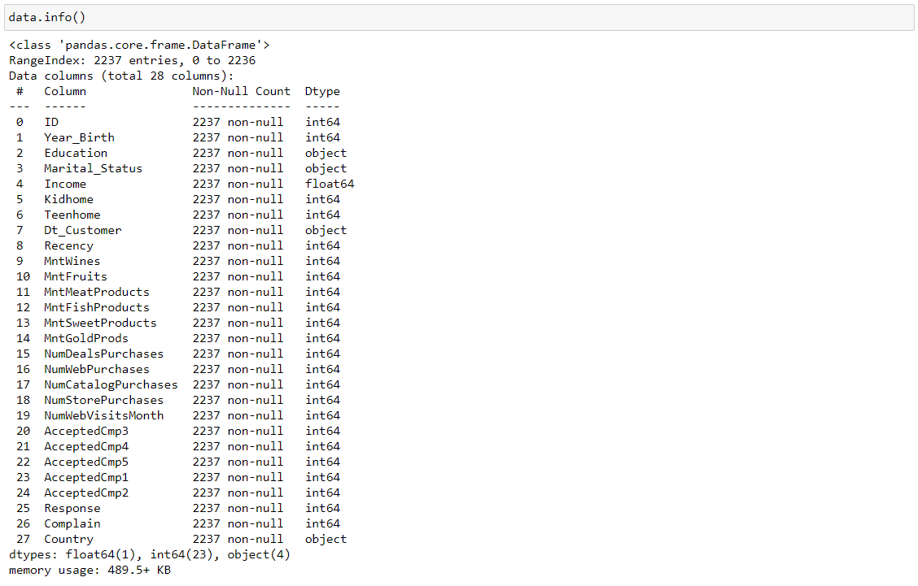

Identifying features containing null values:

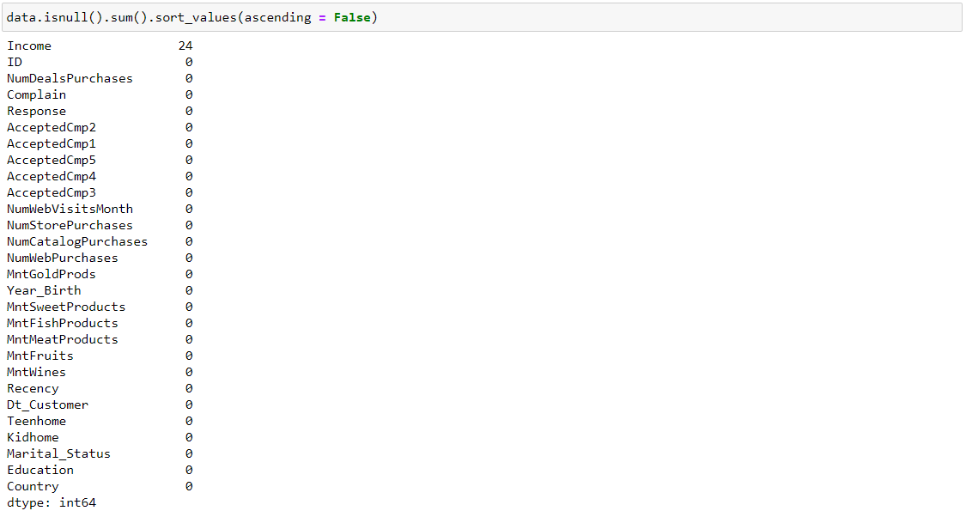

‘Income’ has 24 null values. Plotting the feature set to see the type of imputation to use.

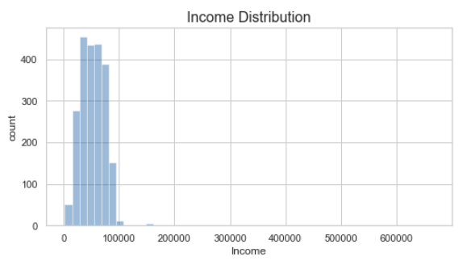

Findings:

• Most incomes are distributed between $0-\$100,000, with a few outliers

• Will impute null values with median value, to avoid effects of outliers on imputation value

Plotting box plot for clarity on the outliers.

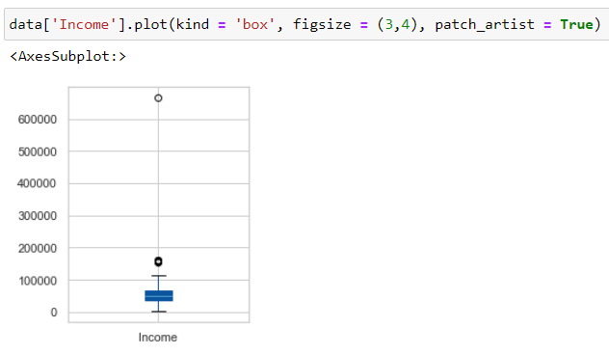

Impute null values in Income, using median value (to avoid skewing of the mean due to outliers). Boxplots provide a great insight for the outliers. Boxplots are made for all the features.

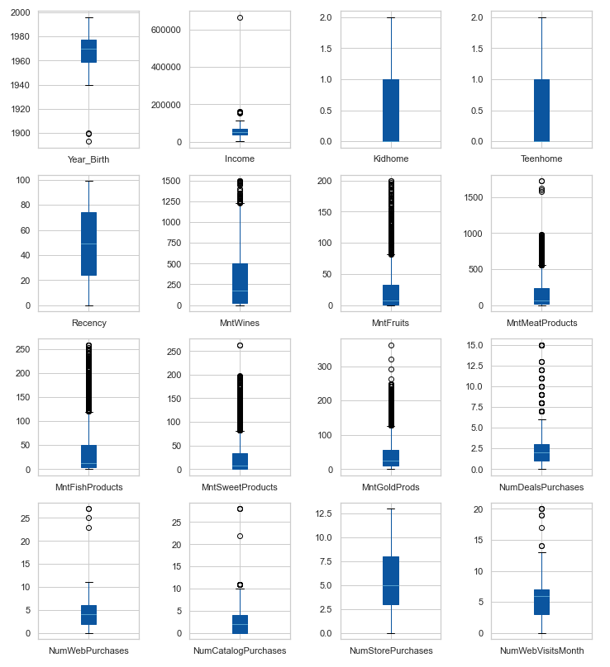

Findings: Multiple features contain outliers (see boxplots below), but the only that likely indicate data entry errors are Year_Birth <= 1900. Removing instances where ‘Year_Birth’ <= 1900.

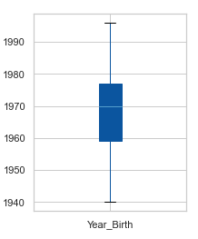

To date, transform Dt Customer as their data type is shown as an object. Many useful data may be gathered from the dataset.

* + 'Kidhome' and 'Teenhome' may be used for the entire number of dependents (Dependents) ,
  + You may build the customer year ("Year Customer") from 'Dt_Customer' .
  + Total Mnt can be computed by summing up all the features including 'Mnt' keyword.
  + Total shopping can be made from all the 'purchases' keyword.
  + TotalCampaignsAcc may be created using 'Cmp' and the 'Response' keywords from all functions (the latest campaign).

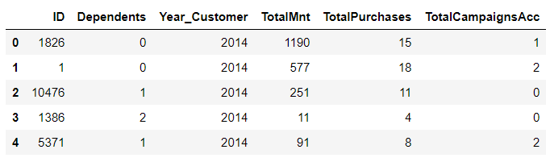

To identify patterns, we will first identify feature correlations. Positive correlations between features appear red, negative correlations appear blue, and no correlation appears grey in the clustered heat map below.

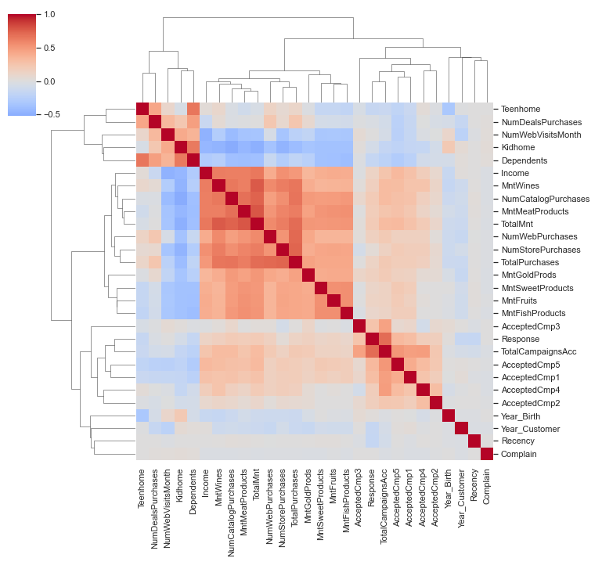

**From this heatmap we can observe the following clusters of correlated features:**

## **The "High Income" cluster:**

Amount spent ('TotalMnt' and other 'Mnt' features) and number of purchases ('TotalPurchases' and other 'Num... Purchases' features) are positively correlated with 'Income'

Purchasing in store, on the web, or via the catalog ('NumStorePurchases', 'NumWebPurchases', 'NumCatalogPurchases') is positively correlated with 'Income'

## **The "Have Kids & Teens" cluster:**

Amount spent ('TotalMnt' and other 'Mnt' features) and number of purchases ('TotalPurchases' and other 'Num... Purchases' features) are negatively correlated with 'Dependents' (with a stronger effect from kids vs. teens)

Purchasing deals ('NumDealsPurchases') is positively correlated with 'Dependents' (kids and/or teens) and negatively correlated with 'Income'

## **The "Advertising Campaigns" cluster:**

Acceptance of the advertising campaigns ('AcceptedCmp' and 'Response') are strongly positively correlated with each other

Weak positive correlation of the advertising campaigns is seen with the "High Income" cluster, and weak negative correlation is seen with the "Have Kids & Teens" cluster

**Anomalies:**

Surprisingly, the number of website visits in the last month ('NumWebVisitsMonth') does not correlate with an increased number of web purchases ('NumWebPurchases')

Instead, 'NumWebVisitsMonth' is positively correlated with the number of deals purchased ('NumDealsPurchases'), suggesting that suggesting that deals are an effective way of stimulating purchases on the website.

The following Plot illustrating negative effect of having dependents (kids & teens) on spending.

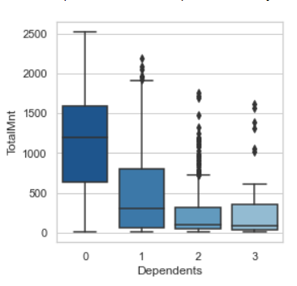

Plot illustrating positive effect of having dependents (kids & teens) on number of deals purchased.

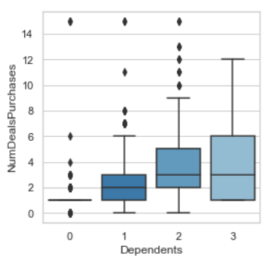

Plots illustrating the positive effect of income and negative effect of having kids & teens on advertising campaign acceptance.

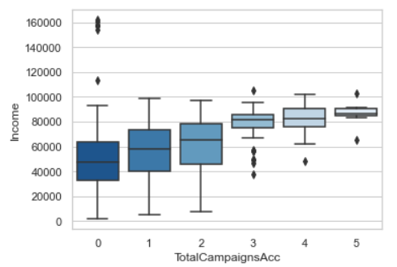

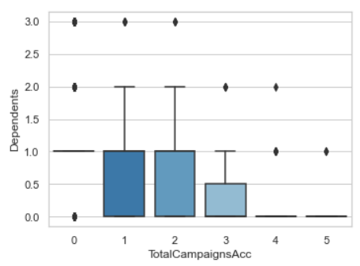

**Investigate anomaly:**

* Number of web visits in the last month is not positively correlated with number of web purchases.
* Instead, it is positively correlated with the number of deals purchased, suggesting that deals are an effective way of stimulating purchases on the website.

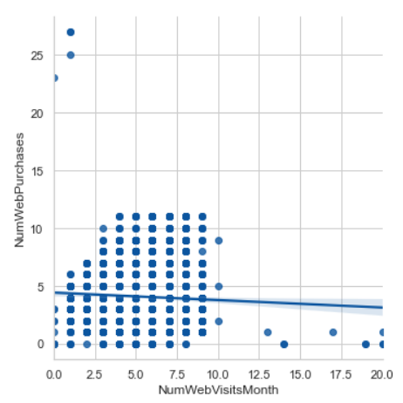

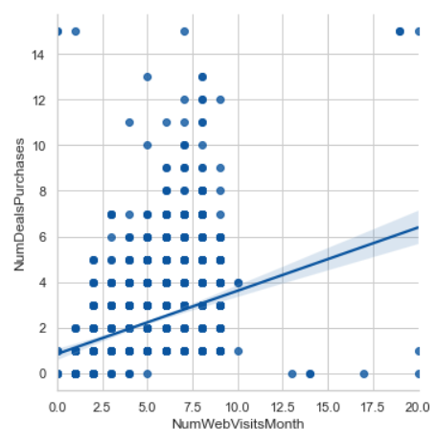

Running statistical tests in the form of regressions to answer questions & propose data-driven action recommendations.

We will use a linear regression model with NumStorePurchases as the target variable, and then use machine learning explain ability techniques to get insights about which features predict the number of store purchases.

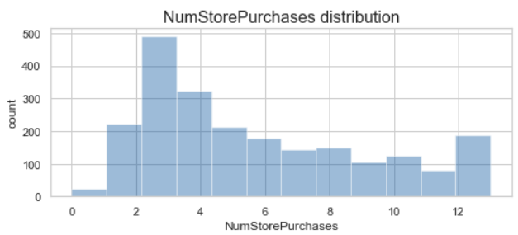

**Drop uninformative features:**

* ID is unique to each customer.
* Dt_Customer will be dropped in favor of using engineered variable Year_Customer

Perform one-hot encoding of categorical features. Fitting Linear regression on the dataset. The results are as follows.

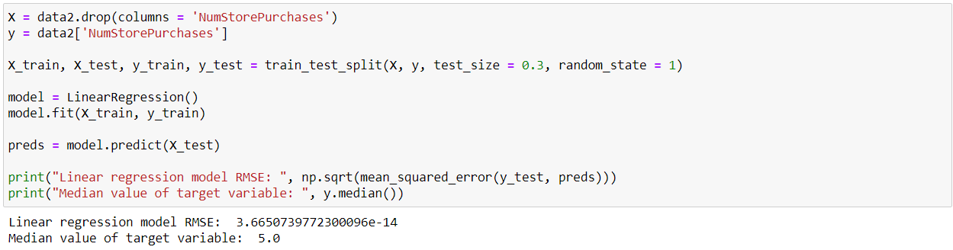

The RMSE is exceedingly small compared to the median value of the target variable, indicating good model predictions. Identify features that significantly affect the number of store purchases, using permutation importance:

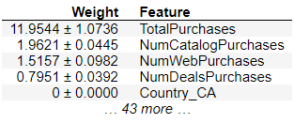

* **Significant features:**
* 'TotalPurchases', 'NumCatalogPurchases', 'NumWebPurchases', 'NumDealsPurchases'.
* All other features are not significant.

Explore the directionality of these effects, using SHAP values:

* **Findings:**
* The number of store purchases increases with higher number of total purchases ('TotalPurchases').
* The number of store purchases decreases with higher number of catalog, web, or deals purchases ('NumCatalogPurchases', 'NumWebPurchases', 'NumDealsPurchases').
* **Interpretation:**
* Customers who shop the most in stores are those who shop less via the catalog, website, or special deals.

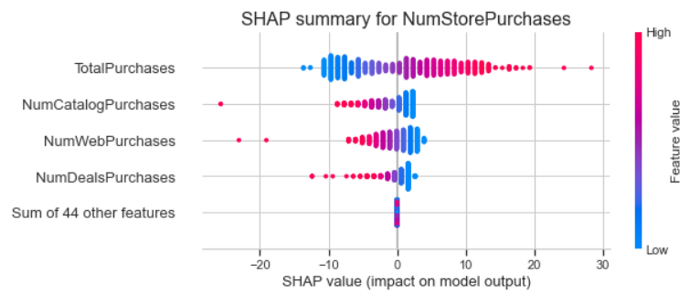

Does the US have considerably better purchasing than the rest of the world?

* Plot total number of nation purchases:
* Findings:
* Spain (SP) has the most purchases
* The US ranks second to last, therefore in the overall number of purchases, the US does not do superior to the rest of the globe.

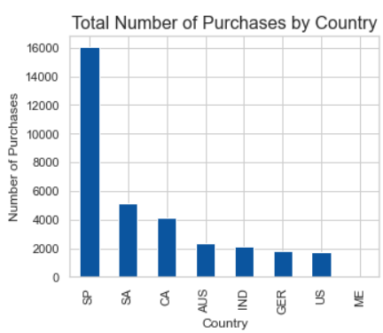

* Findings:
* Spain (SP) has the most purchases
* The US ranks second to last, therefore in the overall number of purchases, the US does not do superior to the rest of the globe.

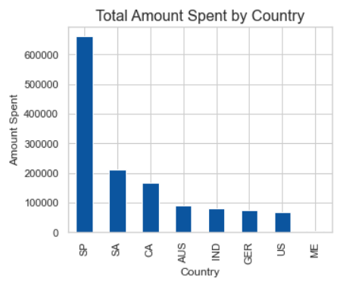

Gold buyers are more cautious. Consequently, persons who had spent a higher average on gold in the previous 2 years would have more to buy. Using an acceptable statistical test, justify or dispute this assertion.

Plot between gold spent over the previous 2 years (MntGoldProds) and retail purchases (NumStorePurchases).

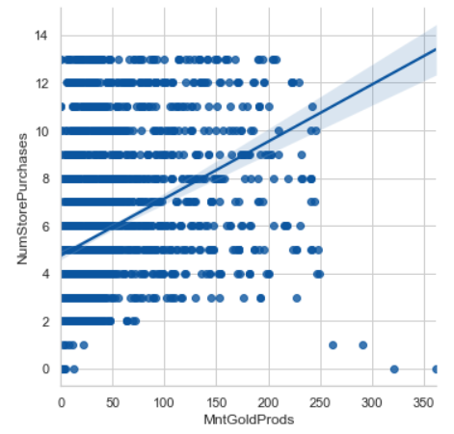

Perform Kendall correlation analysis (non-parametric test since MntGoldProducts is not normally distributed and contains outliers). Findings: There is significant positive correlation between MntGoldProds and NumStorePurchases.

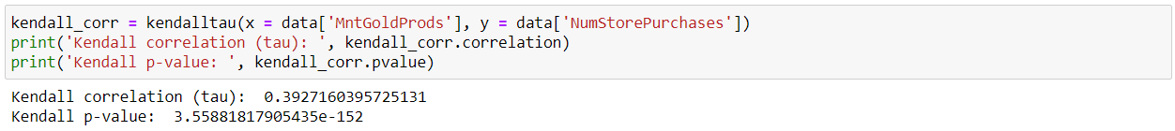

The fatty acids of Omega 3 are helpful for the brain. Do "Married Doctoral Candidates" thus have an important relationship with the amount spent on fish?

We will compare MntFishProducts with all other customers: Married PhD applicants:

**Findings:** In comparison with other consumers, the married PhD candidates spend much less on fish goods.

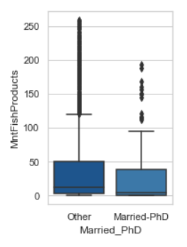

What other factors are significantly related to amount spent on fish?

Like with the analysis of NumStorePurchases above, we will use use a linear regression model with MntFishProducts as the target variable, and then use machine learning explainability techniques to get insights about which features predict the amount spent on fish.

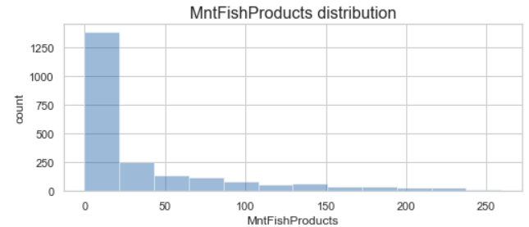

Fit linear regression model to training data (70% of dataset)

Evaluate predictions on test data (30% of dataset) using RMSE:

**Findings:** The RMSE is exceedingly small compared to the median value of the target variable, indicating good model predictions.

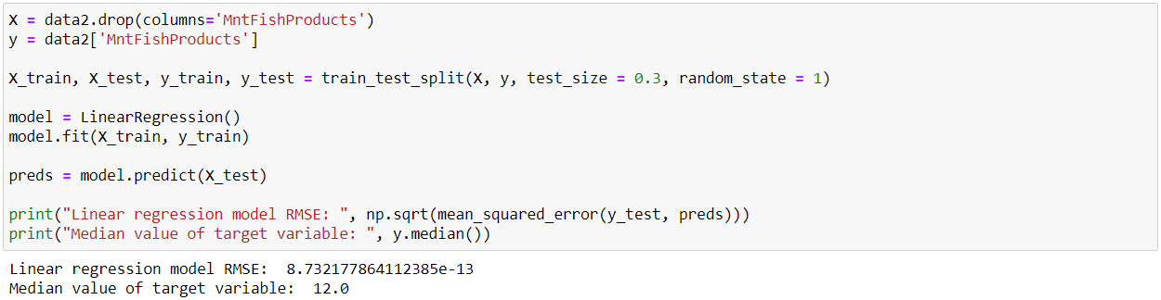

**Identify features that significantly affect the amount spent on fish, using permutation importance:**

**Significant features:**

* 'TotalMnt', 'MntWines', 'MntMeatProducts', 'MntGoldProds', 'MntSweetProducts', 'MntFruits'.
* All other features are not significant.

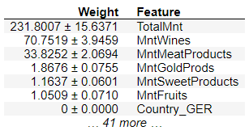

**Explore the directionality of these effects, using SHAP values:**

**Findings:**

* The amount spent on fish increases with higher total amount spent ('TotalMnt')
* The amount spent on fish decreases with higher amounts spent on wine, meat, gold, fruit, or sweets ('MntWines', 'MntMeatProducts', 'MntGoldProds', 'MntSweetProducts', 'MntFruits')

**Interpretation:**

* Customers who spend the most on fish are those who spend less on other products (wine, meat, gold, fruit, and sweets)

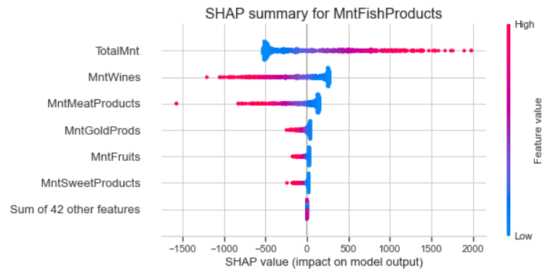

Is there a significant relationship between geographical regional and success of a campaign?

Plot success of campaigns by region:

* Findings:
* The campaign acceptance rates are low overall.
* The campaign with the highest overall acceptance rate is the most recent campaign (column name: Response).
* The country with the highest acceptance rate in any campaign is Mexico.
* Is the effect of region on campaign success statistically significant? See below.

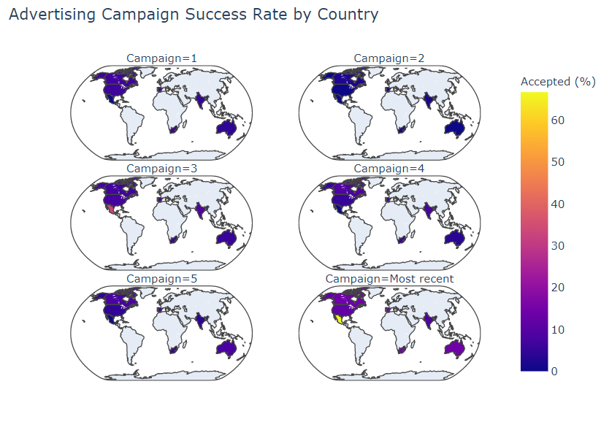

**Statistical summary of regional effects on campaign success:**

**Methodology:** Performed logistic regression for Campaign Accepted by Country, reporting Chisq p-value for overall model.

**Findings:** The regional differences in advertising campaign success are statistically significant.

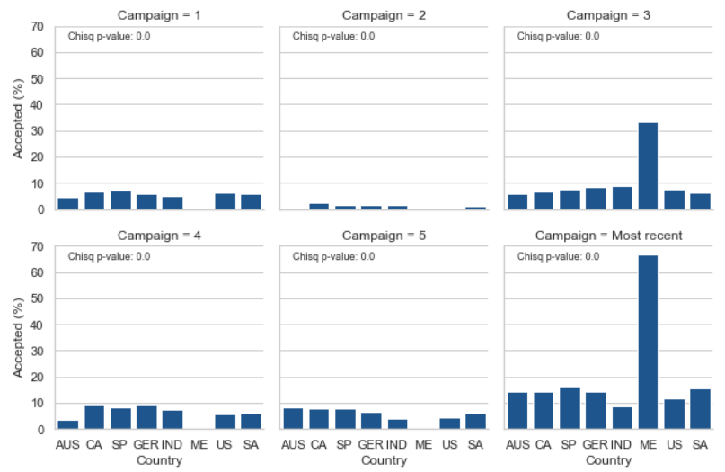

**Plot marketing campaign overall acceptance rates:**

**Findings:** The most successful campaign is the most recent (column name: Response).

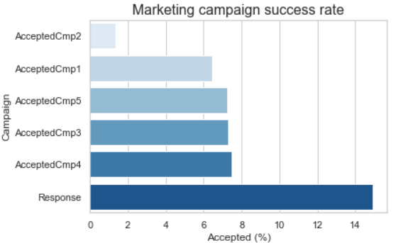

What does the average customer look like for this company?

**Basic demographics:** The average customer is:

* Born in 1969
* Became a customer in 2013
* Has an income of roughly $52,000 per year
* Has 1 dependent (roughly equally split between kids or teens)
* Made a purchase from our company in the last 49 days

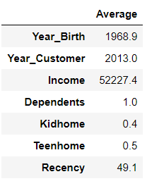

Which products are performing best?

* The average customer spent:
* $25-50 on Fruits, Sweets, Fish, or Gold products
* Over $160 on Meat products
* Over $300 on Wines
* Over $600 total
* Products performing best:
* Wines
* Followed by meats

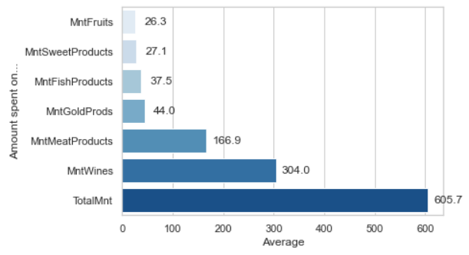

Which channels are underperforming?

* Channels: The average customer:
* Accepted less than 1 advertising campaign.
* Made 2 deals purchases, 2 catalog purchases, 4 web purchases, and 5 store purchases.
* Averaged 14 total purchases.
* Visited the website 5 times.
* Underperforming channels:
* Advertising campaigns.
* Followed by deals, and catalog.

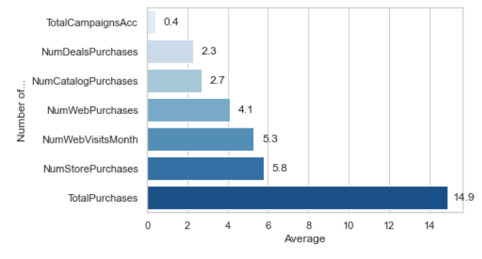

**Summary of actionable findings to improve advertising campaign success:**

The most successful advertising campaign was the most recent campaign (column name: Response), and was particularly successful in Mexico (>60% acceptance rate!).

**Suggested action:** Conduct future advertising campaigns using the same model recently implemented in Mexico.

Advertising campaign acceptance is positively correlated with income and negatively correlated with having kids/teens.

**Suggested action:** Create two streams of targeted advertising campaigns, one aimed at high-income individuals without kids/teens and another aimed at lower-income individuals with kids/teens.

The most successful products are wines and meats (i.e. the average customer spent the most on these items).

**Suggested action:** Focus advertising campaigns on boosting sales of the less popular items.

The underperforming channels are deals and catalog purchases (i.e. the average customer made the fewest purchases via these channels).

The best performing channels are web and store purchases (i.e. the average customer made the most purchases via these channels).

**Suggested action:** Focus advertising campaigns on the more successful channels, to reach more customers.

**UML diagram of DSS:**

Formulation and programming methodologies for Decision Help Systems (DSSs), which are getting more complicated to meet the ever increasing requirements of organizational demands today, and to endorse policy makers (DM) and managers, are attracting great attention. The usage of a Unified Modeling Language (UML) to represent DSSs is described in this study. At a cohesive and systematic manner, we provide an overall model to describe and construct DSSs in all stages of the development process, from issue description to final application. Finally, we apply this technique to the Bay Allocation Problem in a specific case study

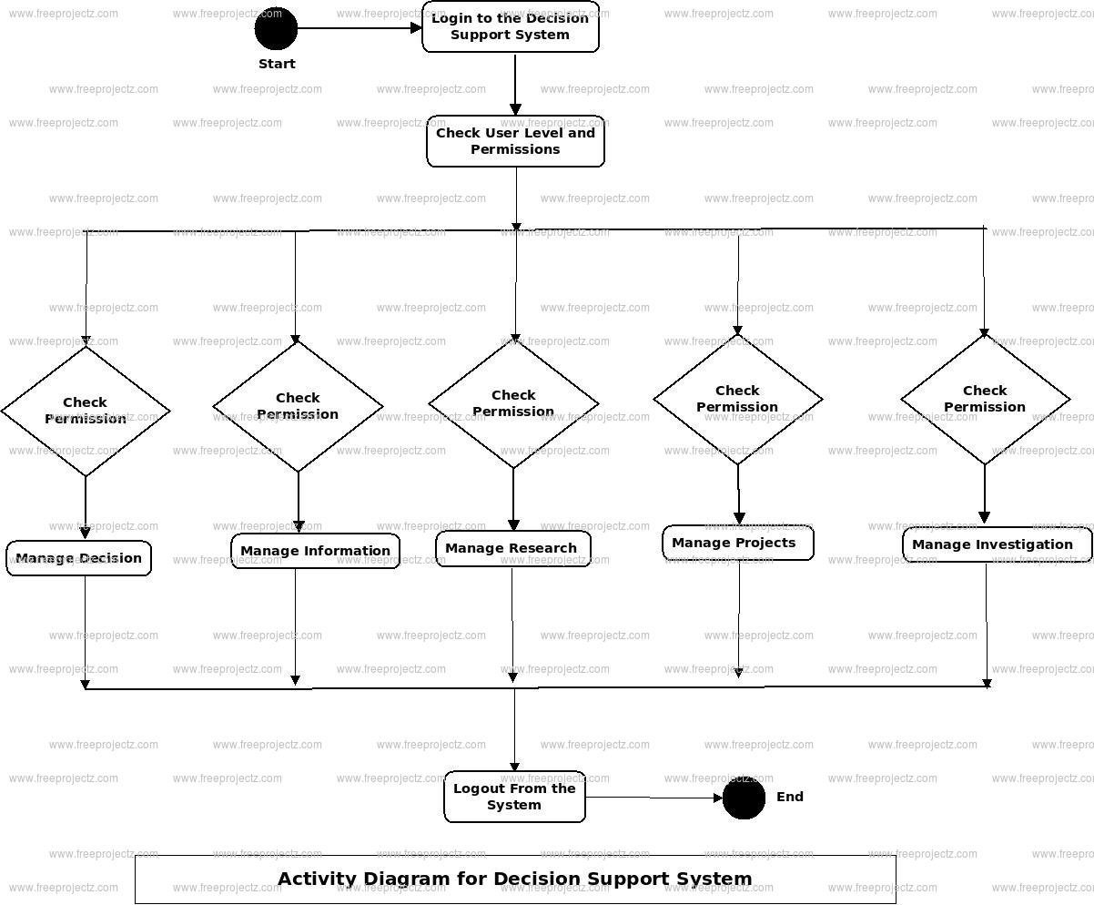

# Figure#09: UML diagram of DSS

**Source:** <https://www.freeprojectz.com/uml-diagram/decision-support-system-uml-diagram>

**Class Diagram of DSS:**

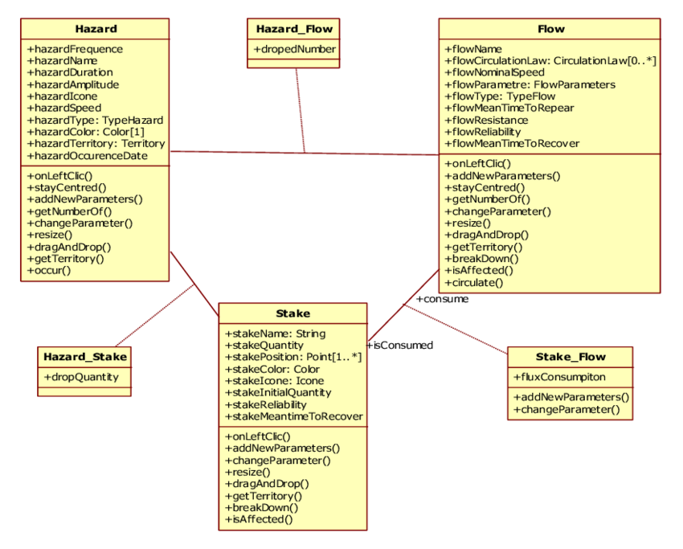

# Figure#10: Class diagram of DSS

**Source:** https://www.researchgate.net/figure/Class-diagram-with-StarUML-8_fig2_260138133

**E-R diagram of DSS:**

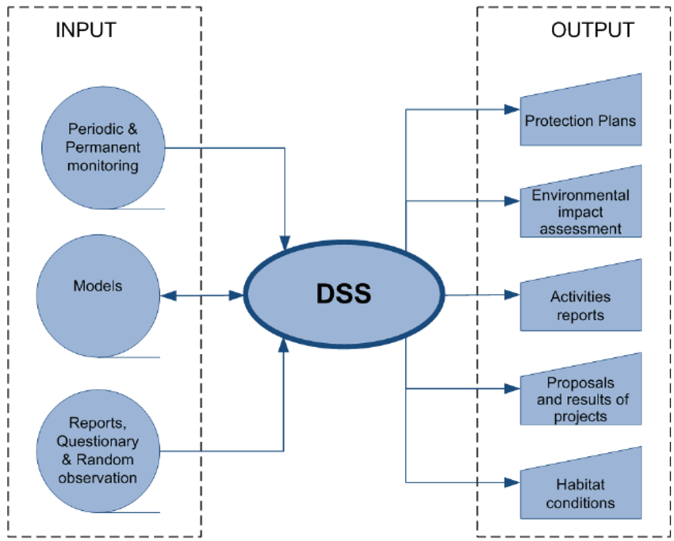

# Figure#11: E-R diagram of DSS

**Source:** https://www.researchgate.net/figure/General-system-diagram-The-main-tasks-of-DSS-is-verification-formatting-storing_fig1_221916051

# **Conclusion**:

Although the production and distribution paradigm is becoming more popular, advantages of standardization really need to satisfy demand changes and seasonal circumstances, fulfil the needs of global suppliers and buyers to preserve goods and provide great customer service. Reduced demand and personalization add to the complexity of warehouse operations which must achieve high performance while ensuring timely delivery.

The proposed DSS supports policymakers who are heavily affected by a range of warehouse operational factors, such as design of warehouses, warehousing equipment and facilities, SK U number, order profile, SKU turnover, Mission Route Policies and performance targets in terms of long term productivity, spatial efficiency and both.

This technology is used for a variety of applications in a real-life environment. First, it helps policy makers make massive difficult objectives based on an assessment of spatial needs and cost in the construction of a new warehouse from below. Secondly, it solves standard size tactical problems such as the size and form of each store and the ability to designate distinct storage facilities for certain SKU classes. The selection of the proper storage capacity for each SKU, which defines the amount reordered by the distribution nodes in the supply chain before, is tactical. Thirdly, the DSS deals with short-term operational choices, determines the most effective routing plan and opts for a re-trivial procedure, namely order against order recovery. The multi-faceted simulation research evaluates the operating performance of each scenario and proposes ideas for improving and increasing the study's operating, strategic and operational scope.

Without much programming labor, DSS delivers several analyses, generally intended for non-technical consumers. Managers usually use the DSS to search, retrieve and analyses information on decision making in order to revisit key issues which allow them to make more informed and informed decisions. Since users often seek correlation between data without rewriting the underlying MIS or the computer program, most of the DSS gives users the graphical capability not only to analyses trends and reports but also helps managers to map the joint analysis and alternative scenarios in order to answer questions. DSS supports both tactical and strategic decisions and builds on management expertise in a particular area.

DSS vary in scope – some are built for multiple (now more common) users and others are stand-alone units (common in the past). Furthermore, DSS may take many different forms and may be used in numerous ways, for example models, data and communications. DSS may be used in many ways. 5 The more the manager is aware of DSS' different categories, scope and aims, the better the criteria for a DSS he wants to install or buy.

In order to comprehend what services a DSS may provide, we first have to look at autonomous units that support the DSS. While DSS may be divided into many different components, I will concentrate mostly on some basic elements of its design. It is important noting, after listing the most critical tasks of a DSS, that a DSS is just as good as the individual components: a data base, a data base and a data model are built up to send data and information to the DSS that is processed and delivered to the user in a simpler way.

The primary feature of DSS is the provision of information used in the decision-making process. The emphasis is not on quantity of information, but on quality. There are several characteristics that categories information as outstanding (e.g. timeliness, relevance, correctness, consistency, impartiality), but the main feature is how information is used to accomplish certain objectives.

Founded on the above functions, various users are supported in a variety of ways. The DSS is designed to provide third-party logistics managers with solutions to common difficulties related to the administration of several customer storage systems with a broad variety of goods, storage racks and turnover. The application delivers an overview of the operational performance of the usual storage area, tactical and operational enhancements and work schedule ideas for different areas. The DSS also enables warehouse managers to simulate operational savings that may be achieved via the integration of allocation and assignment procedures, resulting in innovative slotting strategies. Finally, the DSS provides scientists with the possibility of working on a range of real-world cases, evaluating model utility and heuristic solutions, and learning about the most significant and persistent storing challenges.

It shows the effects of using DDS in three real-life case studies. These profiles were picked in order to validate the system since they demonstrate the wealth and resilience of company data sets. The AS-IS issue provides tremendous progress potential based on a thorough review of the three profiles. Depending on the industrial application, the set of SKUs, the customer goal and the associated research, all three profiles change.

Whatever the business assumptions, DSS uses affinity, popularity or cube-by-purchase indexes to promote a grouping of quick moving SKUs into the most convenient stock areas, creating the need for special golden spaces which can support a wide range of technology, such as transmission and semi-automatic storage. It offers appropriate store capacity for advanced reservation and high-level storage systems including the development of various storage components to enhance collection density and efficiency.

A unique decision support system explains how a picker-to-part storage system is developed and managed. The proposed SDR is an easy-to-use tool for practitioners, managers, policy-makers and logistics providers to design and regulate storage systems via case studies and experimental assessment in the real world. We collect and store data from WMSs using an efficient DBMS architecture and are able to give various data-based solutions and settings. The programme is intended to build multi-zone storage systems and incorporates a variety of strategies and approaches, including storage assignment, assignment, batching, zoning and routing, into several studies.

A what-if simulation research is used to determine performance and cost outcomes and data in a typical warehouse environment. To offer logistics providers and engineers with a ready-to-print warehouse release, a viewing interface has been designed to exhibit two and three-dimensional photographs of the expected storage situation using actual commercial rack elements.

More improvement is expected in the deployment of innovative techniques, models and algorithms to manage the architecture of the warehouse, the storage assignment and challenges in the presence of automated storage solutions and part-time equipment.

A useful module for the barcode scanning with cam interface may be used to introduce and register new SKUs and to manage the SKU's master file. This feature may be utilized to deal with the problem of periodic and complete re-storage instead of a total warehouse renovation.

The instructive aim of this project is to create and distribute information among the most important storage challenges among logistics breadwinners, consultants and administrators and to strengthen the background and skills of industrial engineers. Finally, like any other computer helped system, the required tool has been created to assist the decision-maker, who works in a storage system on a daily basis, instead of replacing him.

Our meta-analysis has expanded our knowledge of how information visualizations are evaluated using a range of heuristics. The technique to compare three distinct heuristics sets generated great results for our case study and showed several features, such as redundancies and conflict, which might be helpful in the broader assessment of various heuristics. We found the use of visualization specific heuristics to be beneficial since they indicated challenges neglected by usability heuristics.

Many of the difficulties we saw were beyond theoretical and knowledge limits, thus the specialists in visualization, usability and the issue would benefit from being included in the review process. Because information visualization focuses on enhancing cognition, heuristics for higher-level cognitive tasks like Amar and Stasko are only the subjects an expert in the field would comprehend. These higher-level problems need a thorough evaluation of whole systems, so that they are not divided and conquered.

A vast deal of study would be necessary to build an effective heuristic taxonomy and a basic set of heuristics which can detect most of the problems or give tremendous help. This is the first step towards achieving these objectives and we want to understand more about the sorts and frequency of problems on the road. Keeping an eye on alternative heuristic organizations and processes that might help to recognize problems and provide answers might be beneficial throughout this investigation.

In order to help create teaching heuristic for combinatory optimization challenges in order that machine learning is used to adaptive autonomous problem solving in real world situations, a generic agent-based framework has been introduced. The framework may be used for various combinatory optimization issues to construct adaptive, autonomously trained versions of current heuristics or metaheuristics and totally new heuristics. Because of the effect on data available for training, an explanation of how the architecture chosen effects the machine learning method and the many possibilities to pick the optimum technique was given.

Whilst many of the approaches described in this work have been used in the past to a range of problems, the literature still appears to have no unifying understanding or even desire to use machine learning to the construction of smarter industrial systems. We think that machine learning has greater potential than it is now possible in the field of intelligent production and production planning and that there is still a surge in associated research. The most important part is a unifying framework for which this article is intended to offer a starting point.

Decision support techniques should benefit from continuous advances in computer and telecommunications infrastructure in order to provide high-performance applications to global decision makers while resolving communicative and collaborative difficulties swiftly and effectively. Decision-makers already have trustworthy information due to data warehouse mining and the usage of analytical tools. This is not enough; data must properly be utilized to create organizational memory, a process which is linked to organizational learning, decision-making and competitive skills issues, as well as to preserve knowledge of the person and the community. It is also important to highlight the changing character of knowledge by studying individual and organizational decision-making perspectives.

In general, situations requiring cooperation between geographically scattered decision makers do not have a clear, accepted formulation or clearly defined action plans. In addition, such difficulty is seldom addressed by formal models or approaches. The best alternative appears to be a style of argumentative practical reasoning (Girle et al., 2003): "an open dialectical process in collaboration to pick and dispute subjects is a strong strategy in which to find the structure of those difficulties" (Buckingham Shum, 2003). In this case, all decision-makers must first identify the main challenges and concerns before offering workable measures and answers. They next identify benefits and disadvantages based on their points of view and perceptions, and express (directly or indirectly) preferences that reveal their views, interests and expectations for each of these actions and solutions. Collaborative decision-making strategies thus contain both a logical and a social component.

All the above difficulties have been fully examined in the proposed decision-making framework. It contributes much by adopting a comprehensive approach to problems.

It states that decision support systems must be modified and integrated more closely to satisfy the demands of organizations that have experience and knowledge. This study and engagement aims at providing a more humane answer to the issue that appropriately shapes and manages the human relationship that underlies this dilemma. The primary policy innovations described in this chapter should be used to gather important information and knowledge as well as reasoning based on earlier instances or rules in all of the discourse-based decision-making cases mentioned. Appropriate ontology frameworks are necessary at this level. An important research route is the introduction of argumentation and test aspects into the decision-making process. The interdisciplinary approach proposed should be combined with intelligent agent technology to allow decision makers to take a variety of tasks and actions in their own name and automate system processes, e. g. by choosing a suitable simulation or decision making model for the problem and by searching the relevant data. Last but not least, flexible user interfaces should be made available.

To sum up, the suggested outline supports more involvement in decision-making processes. This is done via a joint approach to organizational and technological difficulties and the seamless integration of DMSS and AI technology. We suggest that studies will bridge the divide between the approaches studied on both sides with a view to increasing intelligence and aid in multifaceted and dynamic decision-making developments today.

# **References**:

1. Kabashkin, I. (2016) “Heuristic based decision support system for choice of alternative routes in the large-scale transportation transit system on the base of Petri net model,” Procedia engineering, 134, pp. 359–364.
2. Cao, R., Yang, Y. and Guo, W. (2011) “Research on a heuristic GA-based decision support system for rice in heilongjiang province,” in Computer and Computing Technologies in (No date f) Researchgate.net. Available at: <https://www.researchgate.net/profile/Nikos>
3. Karacapilidis/publication/226628133_An_Overview_of_Future_Challenges_of_Decision_Support_Technologies/links/004635176d4ed4a819000000/An-Overview-of-Future-Challenges-of-Decision-Support-Technologies.pdf? origin=publication detail (Accessed: May 29, 2021). Agriculture IV. Berlin, Heidelberg: Springer Berlin Heidelberg, pp. 322–328.
4. Newman, J. P. et al. (no date) Literature review on decision support systems for optimising long-term natural hazard mitigation policy and project portfolios, Com.au. Available at: https://www.bnhcrc.com.au/sites/default/files/managed/downloads/literature_review_on_decision_support_systems.pdf (Accessed: May 29, 2021).
5. St. Clair, P. by T. and Burns, R. (no date) Decision support system literature review and potential implementation scenarios for the Trinity river restoration program, Fws.gov. https://www.fws.gov/arcata/fisheries/reports/tamwg/2013/Jun2013/6_Other_Document_Decision_Support_System_Literature_Review.pdf (Accessed: May 29, 2021).
6. Full Paper (no date) A critical review of decision support systems foundational articles, Core.ac.uk. Available at: https://core.ac.uk/download/pdf/301372548.pdf (Accessed: May 29, 2021).
7. Accorsi, R., Manzini, R. and Maranesi, F. (2014) “A decision-support system for the design and management of warehousing systems,” Computers in industry, 65(1), pp. 175–186.
8. Decision Support System (DSS) (2020) Corporatefinanceinstitute.com. Available at: https://corporatefinanceinstitute.com/resources/knowledge/other/decision-support-system-dss/ (Accessed: May 29, 2021).
9. Wikipedia contributors (2021) Heuristic, Wikipedia, The Free Encyclopedia. Available at: https://en.wikipedia.org/w/index.php?title=Heuristic&oldid=1025517818 (Accessed: May 29, 2021).
10. Accorsi, R., Manzini, R. and Maranesi, F., 2014. A decision-support system for the design and management of warehousing systems. Computers in Industry, 65(1), pp.175-186.
11. Alyoubi, B., 2015. Decision Support System and Knowledge-based Strategic Management. Procedia Computer Science, 65, pp.278-284.
12. Sharma, K. and Virmani, J., 2017. A Decision Support System for Classification of Normal and Medical Renal Disease Using Ultrasound Images. International Journal of Ambient Computing and Intelligence, 8(2), pp.52-69.
13. Ackoff, R. L. 1961. "Management Misinformation Systems," Management Science (14:4), pp. 147-156.
14. Alavi, M. 1982. "An Assessment of the Concept of Decision Support Systems as Viewed by Senior-Level Executives," MIS Quarterly (6:4), pp. 1-9.
15. Alter, S. 1978. “Development Patterns for Decision Support Systems,” MIS Quarterly (2:3), pp. 33-42.
16. Arnott, D. and Pervan, G. 2005. "A critical analysis of decision support systems research." Journal of information technology (20:2), pp. 67-87.
17. Barbosa, L. C., and Hirko, R. G. 1980. "Integration of Algorithmic Aids into Decision Support Systems," MIS Quarterly (4:1), p. 1-12.
18. Davis, R. K. 1979. "Strategic, Tactical, and Operational Planning and Budgeting: A Study of Decision Support System Evolution," MIS Quarterly (3:4), p. 1-19.
19. Elam, J., Huber, G., and Hurt, M. 1986. “An examination of the DSS literature (1975-1985)” in Decision Support Systems: A Decade in Perspective, E.R. McLean and H.G. Sol (editors), Elsevier Science Publishers: North Holland.
20. Eom, S. B. 2003. “Decision Support Systems Research and Reference Disciplines, 1970-2001: A Research Guide to the Literature and an Unobtrusive Bibliography with Citation Frequency”. Edwin Mellen Press.
21. Fleiss, J. L. 1971. "Measuring nominal scale agreement among many raters," Psychological Bulletin (76:5), pp. 378–382.
22. Ginzberg, M. J. 1978. "Redesign of Managerial Tasks: A Requisite for Successful Decision Support Systems," MIS Quarterly (2:1), pp. 39-52.
23. Gorry, G. A., and M. S. Scott-Morton. 1971. "A framework for management information systems." Sloan Management Review (13:1), pp. 49-61.
24. Hackathorn, R. D., and Keen, P. G. W. 1981. "Organizational Strategies For Personal Computing In Decision Support Systems," MIS Quarterly (5:3), pp. 21-27.
25. Henderson, J. C., and Schilling, D. A. 1985. "Design and Implementation of Decision Support Systems in the Public Sector," MIS Quarterly (9:2), pp. 157-169.
26. Hogue, J. T., and Watson, H. J. 1983. "Management's Role in the Approval and Administration of Decision Support Systems," MIS Quarterly (7:2), pp. 15-2.
27. Houdeshel, G., and Watson, H. 1987. "The Management Information and Decision Support (MIDS) System at Lockheed-Georgia", MIS Quarterly (11:1), March, pp. 127-140.
28. Huber, G. P. 1981. "The Nature of Organizational Decision Making and the Design of Decision Support Systems," MIS Quarterly (5:2), pp. 1-10.
29. Hurt, M. E., Elam, J. J., and Huber, G. P. 1986. "The Nature of DSS Literature Presented in Major IS Conference Proceedings (1980-1985)" (1986). ICIS 1986 Proceedings. http://aisel.aisnet.org/icis1986/7.
30. Keen, P. G. W. 1981. "Value Analysis: Justifying Decision Support Systems," MIS Quarterly (5:1), pp. 1-15.
31. Landis, J.R. and Koch, G.G. 1977. “An application of hierarchical kappa-type statistics in the assessment of majority agreement among multiple observers”. Biometrics (33:2), pp.363-374.
32. Locander, W. B., Napier, H. A., and Scamell, R. W. 1979. "A Team Approach to Managing the Development of a Decision Support System," MIS Quarterly (3:1), pp. 53-63.
33. Mann, R. I., and Watson, H. J. 1984. "A Contingency Model for User Involvement in DSS Development," MIS Quarterly (8:1), pp. 27-38.
34. Mason, R. O., McKenney, J. L., and Copeland, D. G. 1997. "Developing an Historical Tradition in MIS Research." MIS quarterly (21:3), pp. 257-278.
35. Mason, R. O., McKenney, J. L., and Copeland, D. G. 1997. “An Historical Method for MIS Research: Steps and Assumptions,” MIS Quarterly (21:3), pp. 307-320.
36. Meador, C. L., Guyote, M. J., and Keen, P. G. W. 1984. "Setting Priorities for DSS Development," MIS Quarterly (8:2), pp. 117-129.
37. Meador, C. L., Guyote, M. J., and Rosenfeld, W. L. 1986. "Decision Support Planning and Analysis: The Problems of Getting Large-Scale DSS Started," MIS Quarterly (10:2), pp. 159-177.
38. Meador, C. L., and Mezger, R. A. 1984. "Selecting an End User Programming Language for DSS Development," MIS Quarterly (8,4), pp. 267-281.
39. O'Keefe, J. B., and Wade, P. F. 1987. "A Powerful MIS/DSS Developed For A Remote Sawmill Operation," MIS Quarterly (11:3), pp. 279-290.
40. Pieptea, D. R., and Anderson, E. 1987. "Price and Value of Decision Support Systems," MIS Quarterly (11:4), pp. 515-528.
41. Pomerol, J. C., & Adam, F., 2006. “On the legacy of Herbert Simon and his contribution to decisionmaking support systems and artificial intelligence”, in Intelligent Decision-making Support Systems, Gupta, Forgionne & Mora (Eds), Springer London, pp. 25-43.
42. Remus, W. E., and Kottemann, J. E. 1986. "Toward Intelligent Decision Support Systems: An Artificially Intelligent Statistician," MIS Quarterly (10:4), pp. 403-418.
43. Remus, W., and Kottemann, J. E. 1987. "Semi-Structured Recurring Decisions: An Experimental Study of Decision Making Models and Some Suggestions for DSS," MIS Quarterly (11:2), pp. 233-243.
44. Robey, D., and Taggart, W. 1982. "Human Information Processing in Information and Decision Support Systems," MIS Quarterly (6:2), pp. 61-73.
45. Sanders, G. L., and Courtney, J. F. 1985. "A Field Study of Organizational Factors Influencing DSS Success," MIS Quarterly (9:1), p. 77-93.
46. Morton, Scott. 1971. "MS (1971) Management decision systems: computer-based support for decision making." Harvard University.
47. Sprague, R, H., Jr., "A Framework for the Development of Decision Support Systems," MIS Quarterly (4:4), pp. 1-26.
48. Todd, P., and Benbasat, I. 1987. "Process Tracing Methods in Decision Support Systems Research: Exploring the Black Box," MIS Quarterly (11:4), pp. 493-512.
49. Turban, E., and Watkins, P. R. 1986. "Integrating Expert Systems and Decision Support Systems," MIS Quarterly (10:2), pp. 121-136.
50. Vierck, R. K. 1981. "Decision Support Systems: An MIS Manager's Perspective," MIS Quarterly (5:4), pp. 35-48.